
ANNUAL HEALTH CHECK ACTION PLAN
NHS No:

LD Nurse: Tel: 01902 444447 444447572572

Name: Date: GP:
Lifestyles   | Body Mass Index Weight Height  kgs cms  Action:
Blood Test and Immunisation  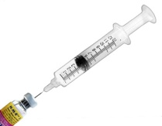 | Blood Test: Yes No  x  x  x  x  Flu Vaccine: Yes No  Blood test results:
Vision   | Regular eye test: Yes No  x  Action:
Hearing   | Ears examined: Yes No  Action:
Oral Health   | Regular dental check: Yes No  Action:
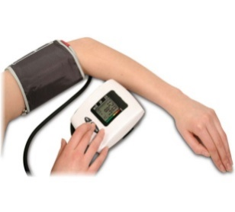  Circulation   | Blood Pressure Pulse  Action:
Breathing   | Diagnosed respiratory condition  Action:
Digestion/Abdomen  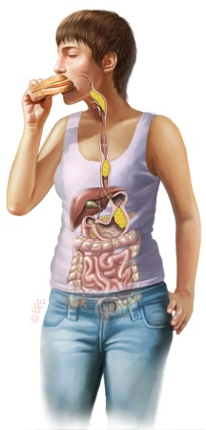 | Abdominal Aortic Aneurysm screen (men 65 yrs and over)  Action:
Bowels & Bladder  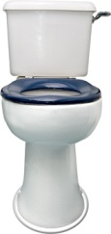 | Bowel Screening (60-69 yrs) Urinalysis  Bowel Scope (55 yrs)  Review of constipation/medication (if applicable)  Action:
Mental Health/Behaviour  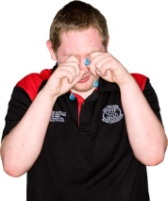 | Mental Health Diagnosis  Action:
Neurology /Endocrine  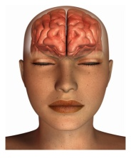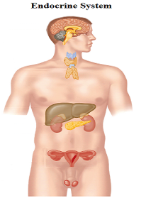 | Diagnosed condition:  Action :
Mobility and Foot Health  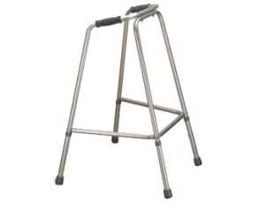 | Postural Care Needs: Yes No  Chiropodist Yes No  Action:
Skin, Hair and Nails   | Diagnosed Skin Condition:  Action:
  Men’s/Women’s Health   | Mammography (47-73 yrs) Cervical Screen (25-64 yrs)  Testicular Check Sexual health  Action:
Medication   | Reviewed: Yes Not prescribed medication  Changes made (consider STOMP):
Actions
1)

2)

3)

4)

5)

